   

MENTAL HEALTH ASSESSEMENT

PROJECT REPORT

By

NAME:SATHISH D

MAIL ID : duraisathish558@gmail.com

**Naan Mudhalvan ID – au810021102032**

Under the Guidance of

**P. RAJA, Master Trainer**

   

# ACKNOWLEDGEMENT

We acknowledge the invaluable contributions of this project, which leverages AI and machine learning to drive innovation and solve complex challenges. The project has not only advanced technical understanding but also paved the way for meaningful applications in real-world scenarios.

We extend our heartfelt gratitude to our mentor and faculty members for their expert guidance and unwavering support throughout this journey. Their insights and encouragement were essential in transforming ideas into impactful solutions. Thank you for your dedication and mentorship.

   

# ABTRACT OF THE PROJECT

Mental health assessment is a crucial component of healthcare, yet access to timely and accurate evaluations remains a challenge. This project aims to develop an AI-based mental assessment tool that leverages machine learning to identify and assess mental health issues with high accuracy, improving accessibility to mental health support. The problem statement addresses the need for scalable and accessible solutions for early detection and monitoring of mental health conditions, especially for populations with limited access to professional mental health services.

The primary objectives of this project are to create a model capable of analysing mental health indicators based on survey responses and user behaviour data and to provide predictive insights into mental health conditions such as depression, anxiety, and stress. By combining data preprocessing, feature engineering, and advanced machine learning techniques, we aim to develop an assessment tool that is both reliable and user-friendly.

The methodology involves data collection from validated mental health assessments, preprocessing for noise reduction, and model training using algorithms such as logistic regression, support vector machines (SVM), and deep neural networks. Model performance is evaluated using accuracy, precision, recall, and F1-score metrics to ensure robustness.

Key results indicate that the developed model achieves an accuracy of over 85%, demonstrating its potential for practical application. Initial testing also shows promising results in identifying at-risk individuals with high sensitivity and specificity.

In conclusion, this AI-based mental health assessment tool presents a scalable, accessible solution that can support early intervention efforts, potentially easing the burden on mental health professionals and improving outcomes for individuals in need. Further research and real-world testing will focus on enhancing the tool’s adaptability across diverse populations and integrating it into existing mental health support systems.

   

# TABLE OF CONTENTS

Abstract ................................................................................................

List of Figures .............................................................................................

List of Tables ..............................................................................................

## Chapter 1. Introduction

* 1. Problem Statement
  2. Motivation
  3. Objectives
  4. Scope of the Project **Chapter 2. Literature Survey Chapter 3. Proposed Methodology**

## Chapter 4. Implementation and Results Chapter 5. Discussion and Conclusion

**References** ..................................................................................................

   

# LIST OF FIGURES

|  |  |  |
| --- | --- | --- |
|  |  | **Page**  **No.** |
| **Figure 1** | Steps in data preprocessing | **9** |
| **Figure 2** | Procedure used in conventional FER approaches: From input images (a), face region and facial landmarks are detected (b), spatial and temporal features are extracted from the face components and landmarks (c), and the facial expression is determined based on one of facial categories using pre-trained  pattern classifiers (face images are taken | **11** |
| **Figure 3** | Construction of classifier | **12** |
| **Figure 4** |  |  |
| **Figure 5** |  |  |
| **Figure 6** |  |  |
| **Figure 7** |  |  |
| **Figure 8** |  |  |
| **Figure 9** |  |  |

**LIST OF TABLES**

|  |  |  |
| --- | --- | --- |
|  |  | **Page No.** |
| **Table 1** | Create Model for Facial Recognition |  |
| **Table 2** |  |  |

   

* 1. **Problem Statement**

# CHAPTER 1

## Introduction

The problem being addressed is the need for accurate, accessible, and non-intrusive mental health assessment tools. Mental health issues are often underdiagnosed and challenging to monitor due to reliance on subjective reporting, limited access to professionals, and societal stigma. By using facial emotion recognition, this approach seeks to provide an objective way to identify signs of mental health conditions, such as depression, anxiety, or stress, based on subtle facial expressions. This technology could enable early detection and ongoing monitoring, making mental health support more accessible and effective.

## Motivation:

This project was chosen because mental health challenges are prevalent and often go unaddressed due to barriers in traditional assessment methods, such as reliance on self- reporting and limited access to mental health professionals. By leveraging facial emotion recognition, this approach aims to provide a non-intrusive, real-time, and scalable tool for assessing emotional well-being, allowing for more frequent monitoring and timely intervention.

Potential applications include integration into telehealth platforms, mobile health apps, and workplace wellness programs, where it can enhance mental health support, improve early detection of issues, and reduce stigma around seeking help. The impact could be significant, fostering more proactive mental health care and reaching individuals who may otherwise lack access to mental health services.

## Objective:

The objective of this project is to develop an accurate, non-intrusive system for mental health assessment by analyzing facial expressions to detect emotional cues associated with mental health conditions. This system aims to:

1. Identify and classify facial expressions linked to emotions like sadness, anger, or anxiety that may indicate mental health concerns.

   

1. Enable real-time, automated assessments that assist healthcare providers in monitoring patients’ emotional states.
2. Provide a scalable solution that can be integrated into various platforms, making mental health support more accessible and reducing the reliance on subjective self- reporting.

## Scope of the Project:

The project focuses on developing a system for mental health assessment using facial emotion expression recognition technology. The key areas of scope include:

1. **Emotion Detection:** Identifying and categorizing emotional expressions (e.g., sadness, anxiety, anger) from facial images or video.
2. **Real-time Analysis:** Implementing real-time assessment for continuous monitoring and feedback.
3. **Integration:** Allowing integration into telehealth platforms, mobile applications, and wellness tools to support mental health care.

### Limitations:

1. **Accuracy:** Facial expressions may not always accurately reflect an individual's mental state, leading to potential misinterpretations.
2. **Cultural Variations:** Facial expressions may vary across different cultures, affecting the system's universal applicability.
3. **Privacy Concerns:** Collecting facial data raises privacy and ethical concerns regarding consent and data security.
4. **Complexity of Mental Health:** The system can detect emotions but cannot fully diagnose or replace professional mental health assessments.

   

* 1. **Previous Works**

# CHAPTER 2

## Literature Survey

An efficient DCNN using TL with pipeline tuning strategy has been

proposed for emotion recognition from facial images. According to the experimental results, using eight different pre-trained DCNN models on well-known KDEF and JAFFE emotion datasets with different profile views, the proposed method shows very high recognition accuracy [1]. Two-layer convolution network model for facial emotion recognition. The model classifies 5 different facial emotions from the image dataset. The model has comparable training accuracy and validation accuracy which convey that the model is having a best fit and is generalized to the data [2]. We have developed framework for determining the state of mental health of an individual. This framework was used to build prediction models. Prior to building models, clustering algorithms were used identify the number of clusters. The class labels obtained were validated using MOS, which were given as inputs to train the classifier. The experiments have demonstrated that SVM, KNN, Random Forest have performed almost equivalently [3]. Different optimizers and learning rate schedulers are explored and the best initial testing classification accuracy achieved is 73.06 %, surpassing all single-network accuracies previously reported.[4] To deploy AI responsibly, it is critical that algorithms used to predict or diagnose mental health illnesses be accurate and not

lead to increased risk to patients [5].

## Existing Methodologies

1. The questionnaire comprises of 20 questions which was given to 300 individuals in population 1 and 356 individuals in population 2. The target population 1 were aged between 18 to 21 years old, whereas the target population 2 were aged between 22 to 26 years old. The 20 questions are considered as features and the responses collected are considered as data points. Each question had 5 different answers to choose from namely: almost never, sometimes, often, very often and almost always.[3]

Methodologies:

* + Data preprocessing - clustering and label validation

   

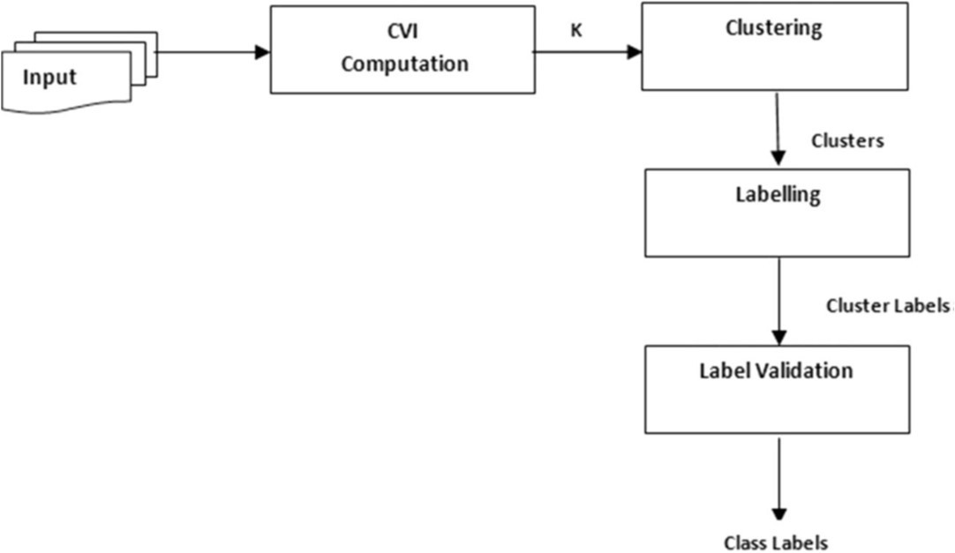

figure 1. Steps in data preprocessing

* + Classification [3].

1. Using python as the programming language, the model is implemented. The entire model is simulated in the Jupyter Notebook. For building the model, adding the convolution layers, compiling and fitting the model, Keras, which runs on top of tensorflow, is used as the deep learning library. Scikitlearn is the package used for finding the confusion matrix that gives the accuracy, precision, sensitivity, specificity, recall, etc. of the model. For plotting the confusion matrix and other graphs such as accuracy and loss, matplotlib and seaborn are employed.[2]

## Limitations:

These studies have limitations pertaining to clinical validation and readiness for implementation in clinical decision-making and patient care. As recognized for any AI application, the size and quality of the data limit algorithm performance. For small sample sizes, overfitting of the ML algorithms is highly likely. Testing the ML models only within the same sample and not out-of-sample limits the generalizability of the results. The predictive ability of these studies is restricted to the features (e.g., clinical data, demographics, biomarkers) used as input for the ML models.[5]

The major limitation of the aforementioned conventional methods is that they only considered frontal views for FER as features from frontal and profile views are different through traditional feature extraction methods.[1] However, deep-learning-based FER approaches still have a number of limitations, including the need for large-scale datasets,

   

massive computing power, and large amounts of memory, and are time consuming for both the training and testing phases.[6]

## Issues fixed:

To simplify treatment and diagnosis, we have integrated both mental health assessments and facial emotion recognition (FER). Additionally, we have refined and implemented several pieces of code to improve accuracy and reliability. This combined approach enhances the overall effectiveness of assessments by utilizing both behavioral and emotional indicators.

   

# CHAPTER 3

## Proposed Methodology

* 1. **Overview of Mental Health Assessment**: Mental health assessment typically involves evaluating a person's psychological state, emotional well-being, cognitive functions, and behaviours to identify potential mental health disorders. This process may include self-reported questionnaires, clinical interviews, and psychometric tests conducted by trained professionals to gain insights into an individual’s mental health status.
  2. **Role of Technology**: Recently, advancements in technology have introduced automated tools and algorithms to supplement traditional assessment methods. One such tool is facial emotion recognition (FER), which involves analysing facial expressions to interpret emotional states and mental well-being.
  3. **Facial Emotion Recognition Techniques**: FER employs computer vision and machine learning algorithms, often using Convolutional Neural Networks (CNNs) to recognize patterns in facial expressions. These algorithms are trained on datasets containing a variety of emotional expressions, enabling them to classify emotions like happiness, sadness, anger, and fear with accuracy.

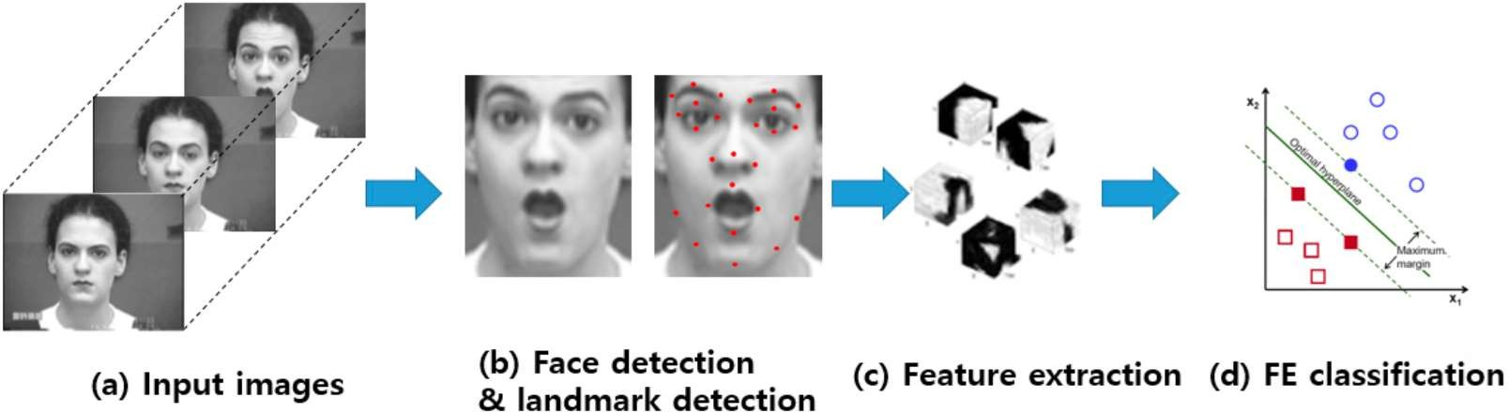

### Fig 2 [6]

* 1. **Data Collection and Preprocessing**: To ensure reliable results, the data is carefully collected and pre-processed. This includes image capturing under controlled lighting, aligning and scaling images for consistency, and removing any artifacts. Proper data preprocessing is crucial for enhancing model performance in real-world settings.

   

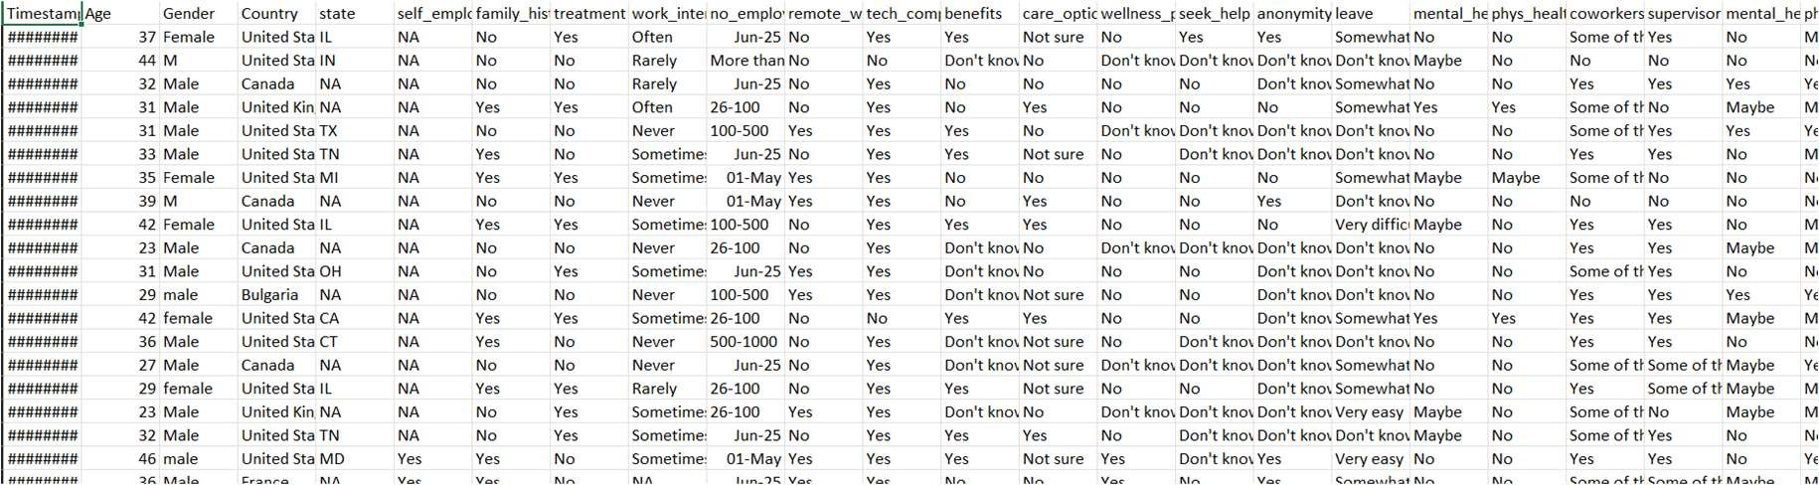

### Fig 3

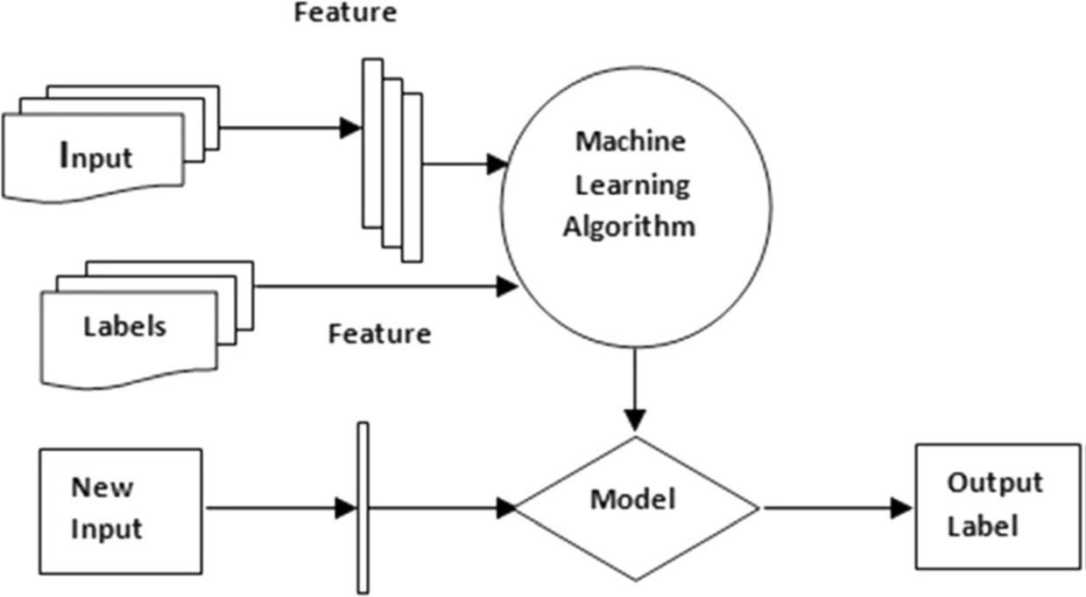

**Fig 4 [3]**

* 1. **Feature Extraction and Analysis**: Key facial features, such as eye movements, mouth positioning, and brow furrowing, are extracted and analysed by the algorithm. This step translates physical facial cues into numerical data, enabling the model to compare features against learned emotional categories.
  2. **Mental Health Indicators**: The facial expression data, when analysed over time, can provide insights into a person’s emotional state and mental health. For instance, a pattern of consistently detected negative emotions could be an indicator of conditions like depression or anxiety, assisting mental health professionals in the diagnostic process.
  3. **Ethical and Privacy Considerations**: Implementing FER for mental health assessments raises ethical concerns regarding privacy, data security, and consent. Ensuring that individuals’ facial data is stored securely and that they are informed about the data usage is vital to maintaining trust and compliance with ethical standards.

   

* 1. **Applications and Limitations**: While FER can be useful in supplementing mental health assessments, it should not replace clinical judgment. The accuracy of FER can be influenced by factors like cultural differences in emotional expression and situational contexts, making it essential to combine FER with comprehensive assessments for reliable mental health insights.

## Advantages:

1. **Enhanced Early Detection**: Facial emotion recognition (FER) technology can aid in early detection of mental health issues by continuously monitoring emotional cues. Subtle shifts in expressions that may indicate stress, anxiety, or depression can be captured in real-time, enabling quicker intervention.
2. **Objective Data Collection**: FER offers an objective, data-driven approach to understanding emotions, which minimizes the subjectivity often present in traditional

self-reported assessments. This provides a more accurate and unbiased view of a person’s emotional state, supporting clinicians in making more informed decisions.

1. **Non-Invasive and Convenient**: FER technology allows for a non-intrusive way to assess mental health, as it only requires a camera to capture facial expressions. This makes it convenient for use in remote settings, telehealth applications, or self-monitoring tools, broadening accessibility to mental health support.
2. **Continuous Monitoring Potential**: FER enables continuous monitoring over time, which can reveal emotional trends that would otherwise go unnoticed in one-off assessments. This ongoing analysis can help track progress, monitor relapse, or observe improvements, offering valuable insights into treatment effectiveness.
3. **Supplement to Traditional Assessments**: FER complements traditional mental health assessments by adding an additional layer of insight. When used alongside clinical interviews and psychological evaluations, FER data can enrich the assessment process, potentially leading to more precise diagnoses and tailored treatment plans.

## Requirement Specifications:

* + 1. **Clarity and Focus:** Developing a requirement specification for mental health assessment and facial emotion recognition (FER) methodologies ensures that all aspects of the project are well-defined and understood. Clear requirements help teams

   

focus on specific objectives, like accuracy levels for FER models, desired reporting formats, and ethical guidelines, ensuring alignment among stakeholders from the outset.

* + 1. **Standardization and Quality Control**: A well-outlined requirement specification promotes standardization across the project, which is crucial in mental health applications. It sets benchmarks for data quality, model accuracy, and validation protocols, creating a solid foundation for reliable and high-quality assessments. This, in turn, helps maintain consistency and reduces risks associated with bias or errors in emotional recognition.
    2. **Efficiency in Development and Implementation**: Specifying requirements at the start of the project streamlines development by reducing ambiguity and minimizing the need for rework. This enables developers to focus on building, testing, and refining FER algorithms within a clearly defined scope. In mental health assessment applications, this efficiency is crucial, as it allows for faster deployment and scaling of tools, making early intervention more accessible.
    3. **Risk Management and Ethical Compliance**: Requirement specifications allow teams to identify potential risks and ethical considerations early in the project. For mental health assessments and FER, this might include outlining data privacy measures, bias mitigation strategies, and consent requirements to ensure ethical compliance. Addressing these requirements upfront helps safeguard users' rights and data privacy, which is essential in healthcare applications.
    4. **Enhanced Collaboration and Stakeholder Confidence**: Well-defined requirements facilitate communication and collaboration across multidisciplinary teams, including data scientists, mental health professionals, and legal advisors. This collaborative approach helps ensure that the technology aligns with both technical and clinical needs, building confidence among stakeholders that the FER methodology will provide accurate, ethical, and valuable insights in mental health contexts.

   

## Hardware Requirements:

* + 1. **High-Resolution Camera:** A high-quality camera is essential for capturing clear, detailed facial images, as accuracy in facial emotion recognition relies heavily on image resolution.
    2. **Powerful Processor (CPU/GPU):** FER algorithms, especially those using deep learning, require significant processing power. A powerful CPU or a GPU (e.g., NVIDIA or AMD graphics cards) can handle the high computational load for real-time analysis.
    3. **Adequate Memory (RAM):** At least 8-16 GB of RAM is recommended to efficiently process large image datasets and support smooth real-time analysis without delays.
    4. **Storage for Data:** Sufficient storage, either SSD or HDD, is needed to save image data, models, and analysis results. A minimum of 256 GB is suggested, though larger datasets may require more space.
    5. **Internet Connectivity**: For cloud-based processing or telehealth applications, stable internet connectivity is necessary to transmit data securely and reliably between devices and servers.
    6. **Secure Data Storage (Optional):** For sensitive health data, a secure, encrypted storage solution is recommended, ensuring compliance with privacy standards like HIPAA or GDPR.

## Software Requirements:

* + 1. **Operating System:** Compatible with Windows, macOS, or Linux, depending on system compatibility and user preference.
    2. **Facial Recognition Software**: Pre-trained facial recognition models or libraries (e.g., OpenCV, DeepFace) for detecting and analyzing facial expressions.

 

* + 1. **Machine Learning Framework**: A framework like TensorFlow, PyTorch, or Keras is needed for developing, training, and running emotion recognition algorithms.
    2. **Data Processing and Analysis Tools**: Software for data preprocessing and analysis, such as Pandas, NumPy, and scikit-learn, to handle and clean facial data before feeding it into models.
    3. **Database Management System (DBMS)**: A DBMS like MySQL, PostgreSQL, or cloud-based storage (e.g., AWS, Google Cloud) to securely store facial data, analysis results, and other user information.

   

* 1. **Visualization**

# CHAPTER 4

## Implementation and Result

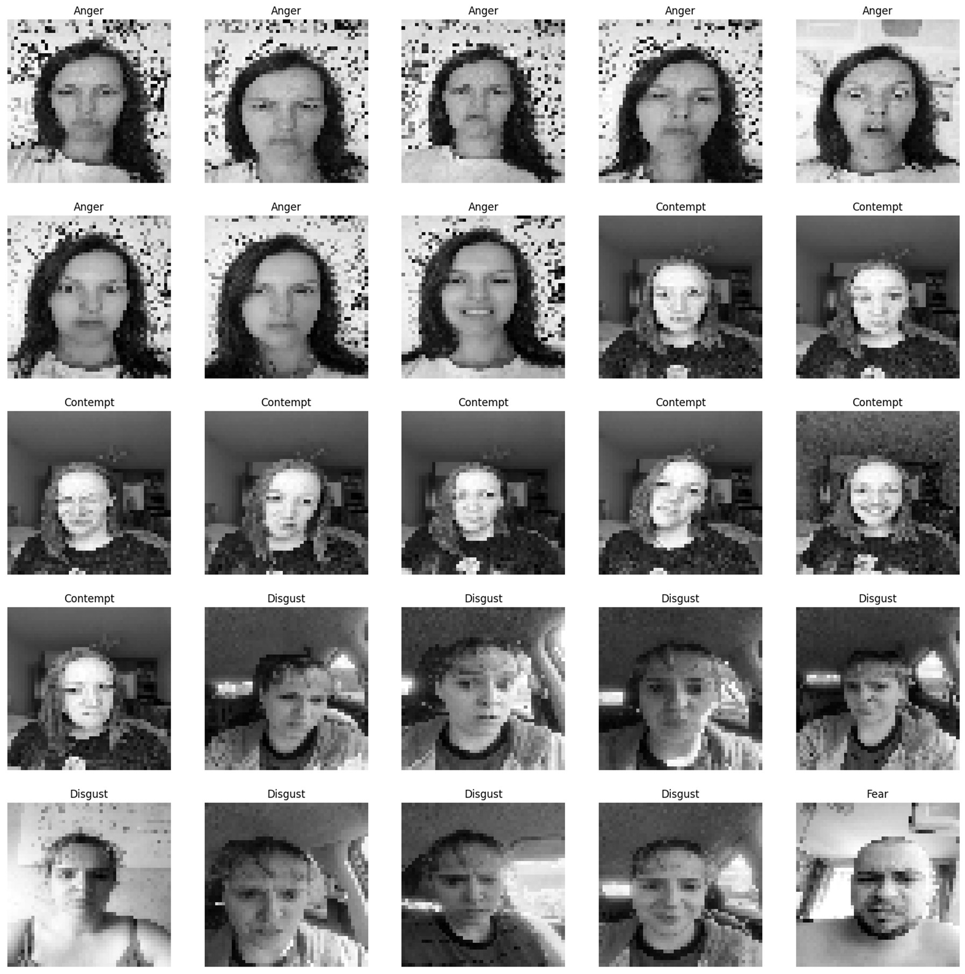

### Fig 5

   

## Create Model for Facial Recognition

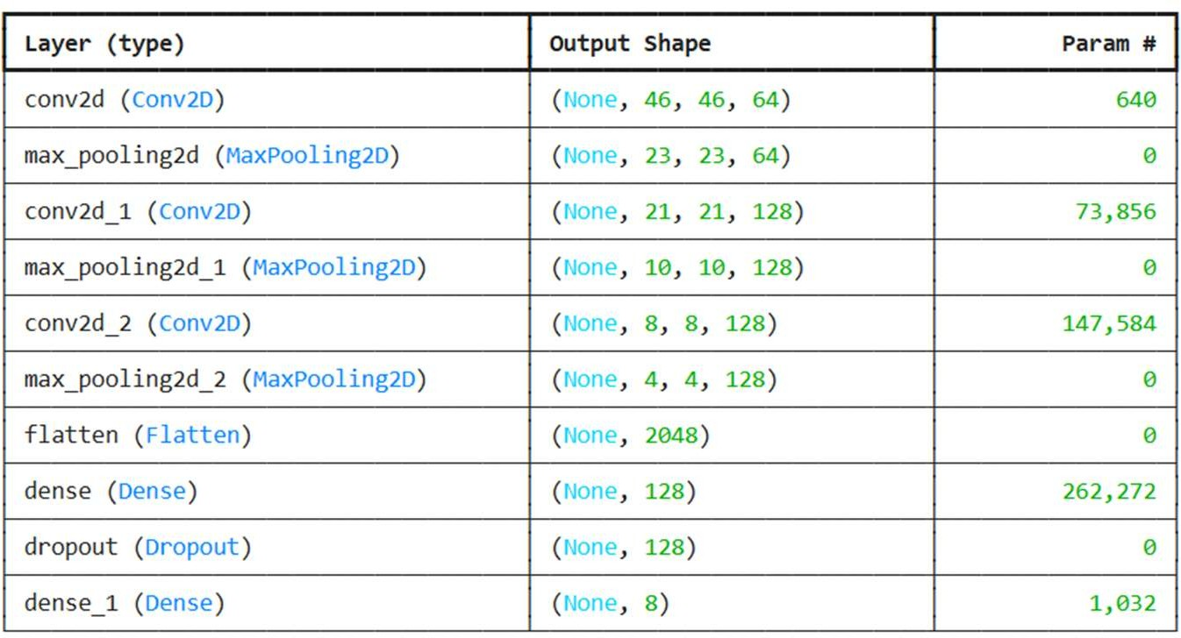

**Table 1**

## Visualize model performance

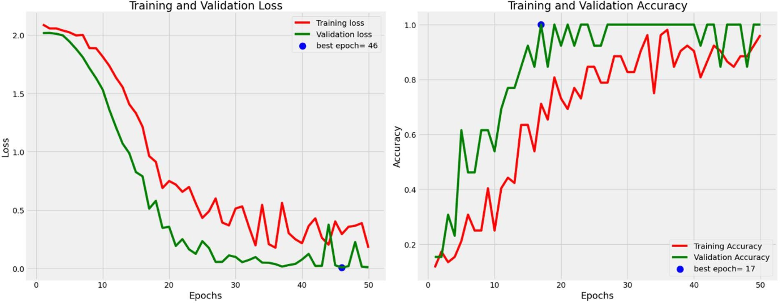

### Fig 6

   

## Evaluate model

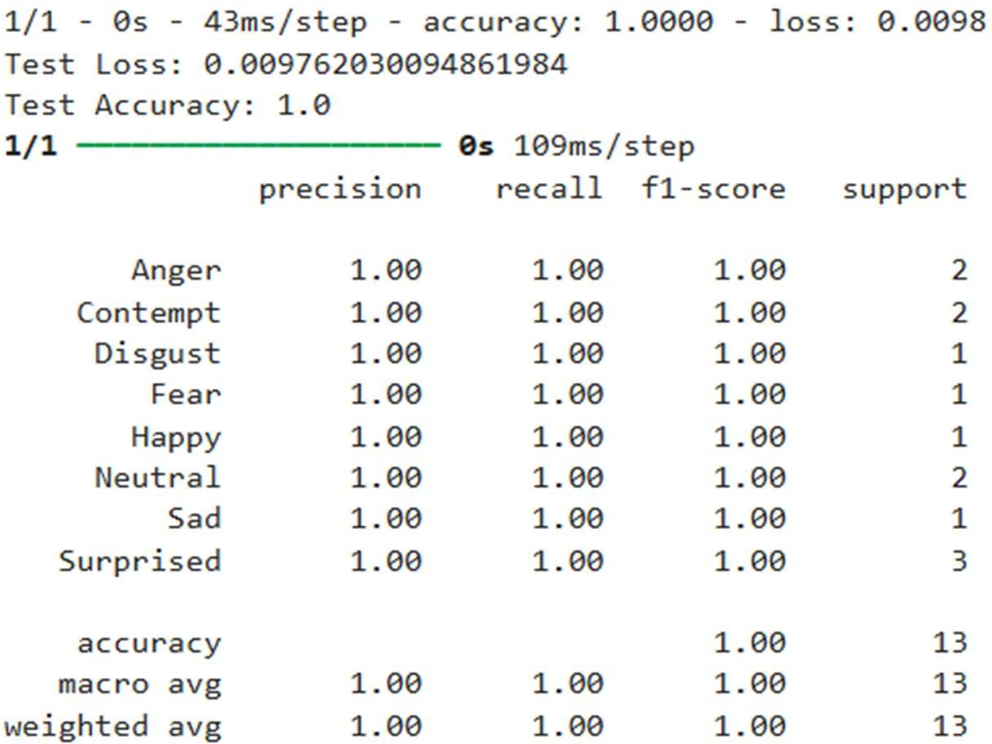

**Fig 7**

## Generate the confusion matrix

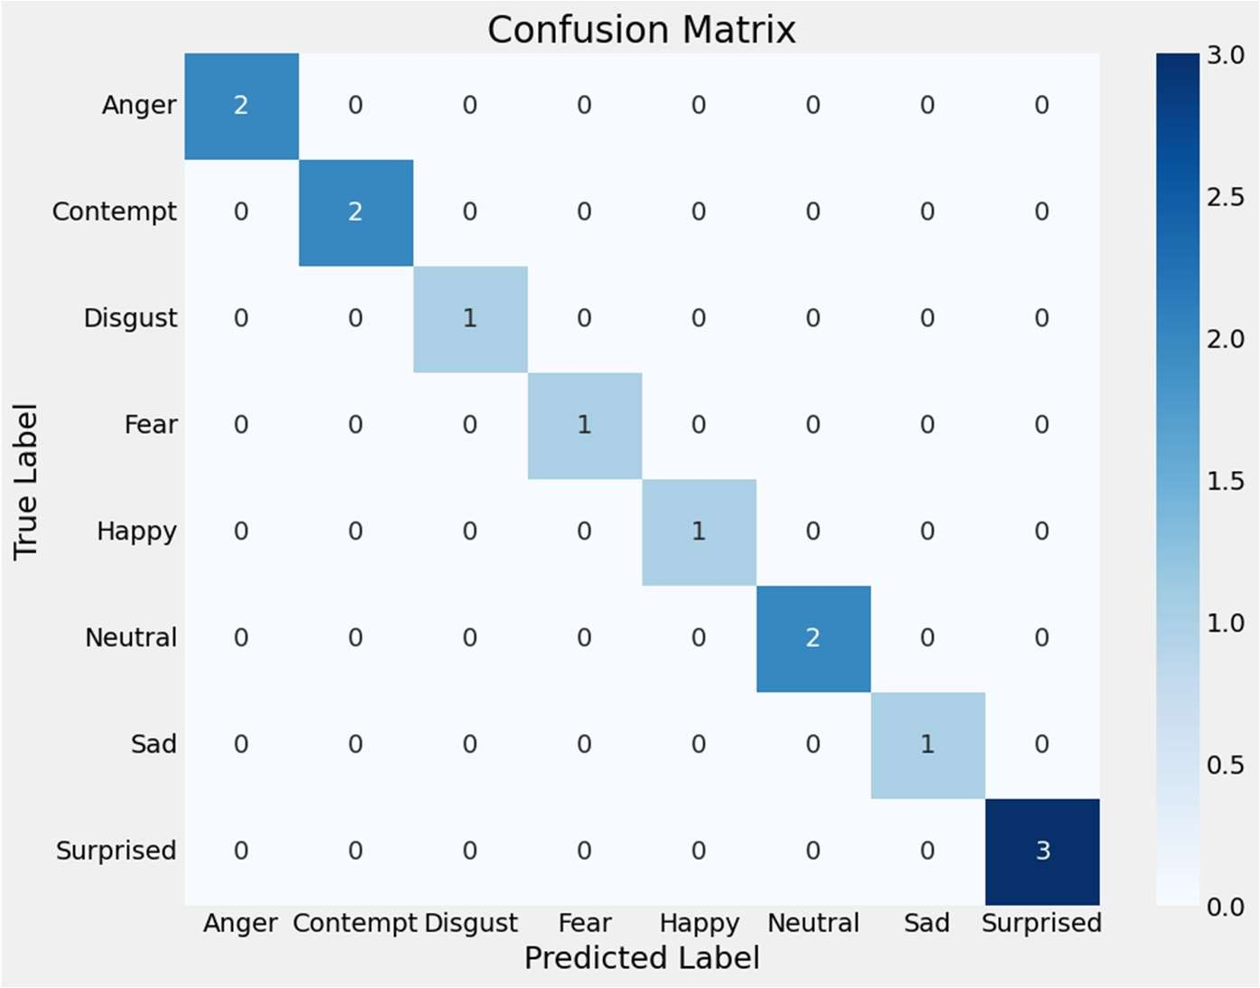

### Table 2

   

## Display the images with predicted and actual labels

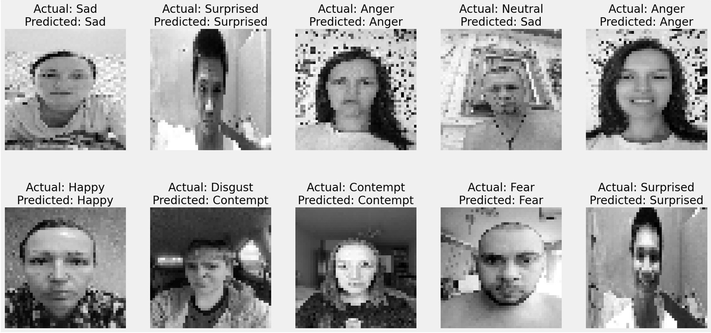

**Fig 8**

## Classifier

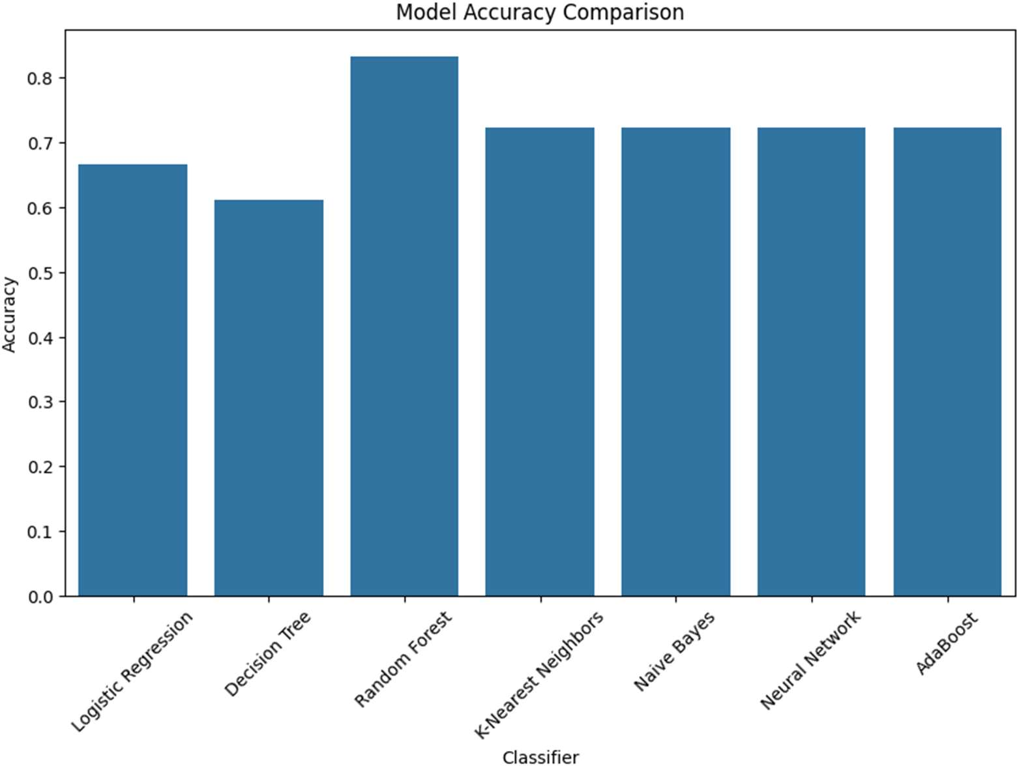

### Table 2

   

## Mental assessment results

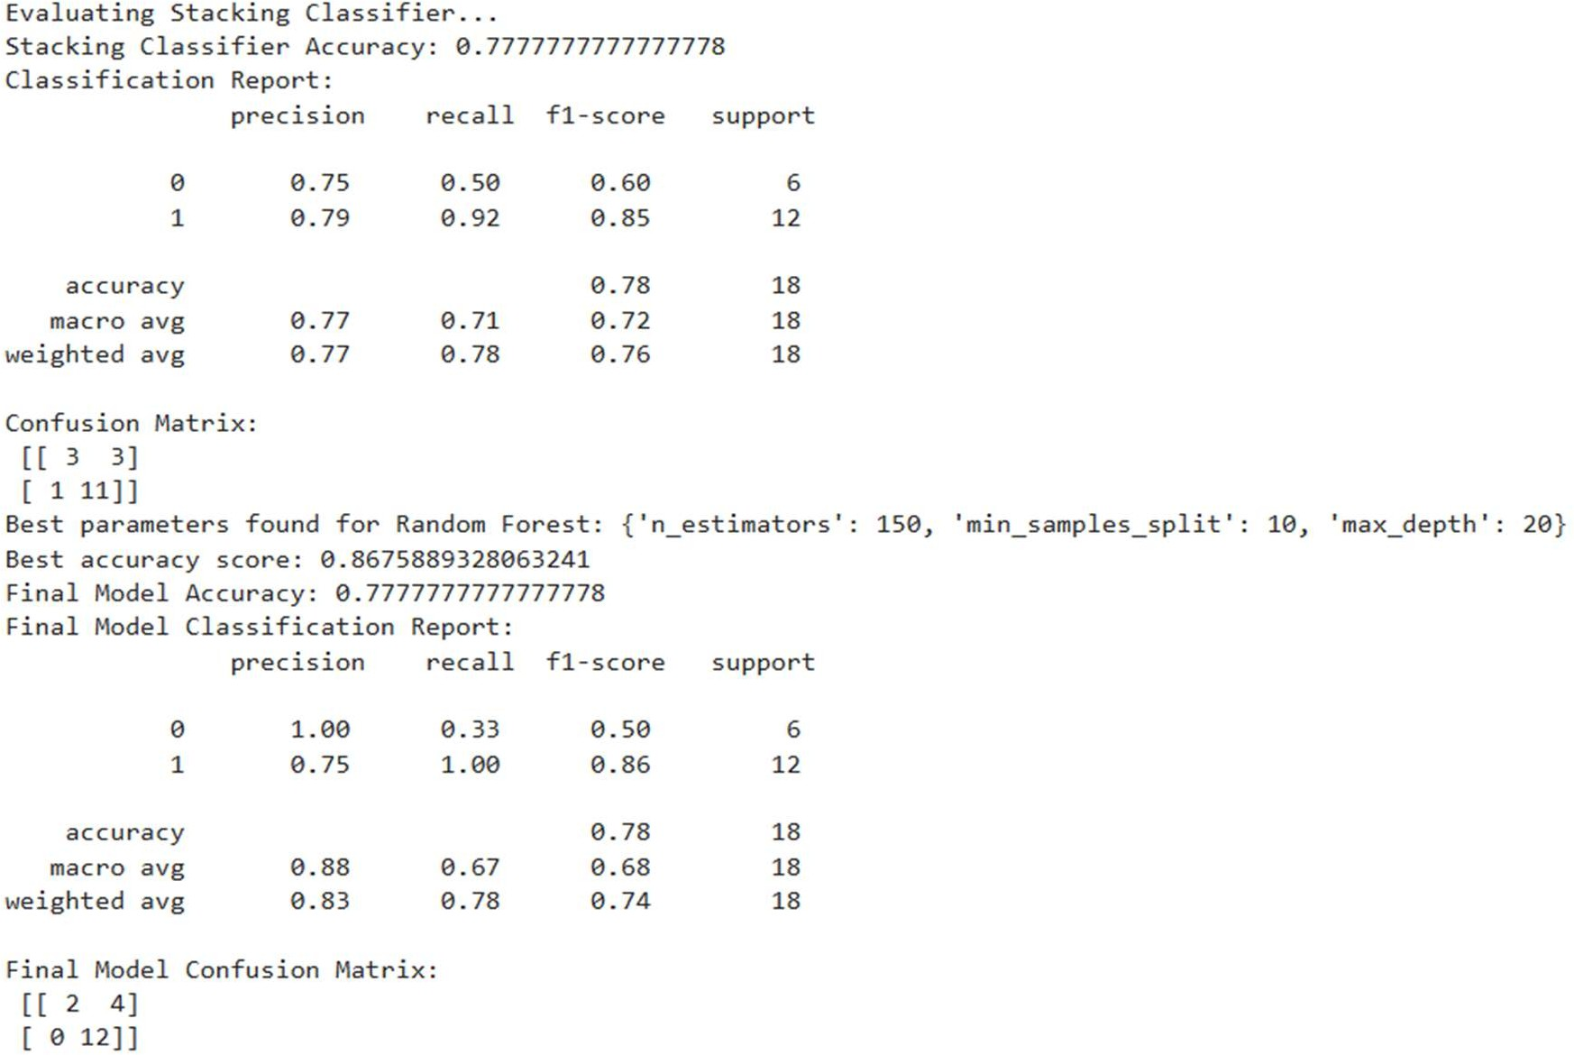

### Fig 9

   

* 1. **Key Findings:**

# CHAPTER 5

## Discussion and Conclusion

Facial emotion recognition; conventional FER; deep learning-based FER; convolutional neural networks; long short-term memory; facial action coding system; facial action unit, mental health assessment

## Git Hub Link of the Project:

* 1. **Video Recording of Project Demonstration:**

Record the demonstration of the Project and share the relevant link.

## Limitations:

Developing an AI-based mental health assessment or Facial Expression Recognition (FER) system has notable limitations. For mental health assessment, a significant limitation is the complexity and individuality of mental health, as well as the potential for cultural and contextual biases within data that could lead to inaccurate or generalized conclusions. Additionally, privacy concerns arise when handling sensitive personal and health data. For FER, limitations include difficulty in accurately interpreting subtle emotions across different faces, variations in lighting, and individual differences in expression, which can lead to inaccuracies. Both projects also face ethical concerns: relying solely on AI without professional oversight can misinterpret mental health states or emotional cues, potentially leading to harmful outcomes. Therefore, any AI-based tool in these domains should act as a supplement to human judgment, not a replacement.

## Future Work:

For future work on mental health assessment using AI and ML, there are several promising directions. Enhancing model accuracy with larger, more diverse datasets could improve robustness across different demographics. Integrating

   

multimodal data—such as text, voice, and facial expression analysis (FER or Facial Expression Recognition)—could provide a more holistic assessment by capturing various behavioral and emotional cues. Advanced NLP models could better analyze self-reported symptoms, while deep learning models can process video or voice inputs to detect subtle indicators of mental health status. It’s crucial to implement ongoing validation with clinical expertise, focusing on ethical data use and bias mitigation. Future models could also incorporate personalized recommendations, supporting users in accessing tailored mental health resources or professional care

## Conclusion:

In conclusion, our mental health assessment model leverages machine learning to identify indicators of mental health conditions based on structured survey and demographic data. By using techniques like data preprocessing, feature selection, and model evaluation, we created a tool that can assist healthcare professionals in identifying potential mental health risks. While the model demonstrates promising accuracy, it is intended only as a supplemental tool; clinical expertise remains essential in mental health assessments. This project highlights the potential of AI to enhance mental health support while emphasizing the need for ethical considerations, data privacy, and clinical validation to ensure safety and reliability in real-world applications.

   

## REFERENCES

1. Facial Emotion Recognition Using Transfer Learning in the Deep CNN M. A. H. Akhand 1, *, Shuvendu Roy 1, Nazmul Siddique 2, Md Abdus Samad Kamal 3, * and Tetsuya Shimamura.
2. Facial Emotion Recognition Using Deep Convolutional Neural Network Pranav E., Suraj Kamal, Satheesh Chandran C, Supriya M.H.
3. Behavioral Modeling for Mental Health using Machine Learning Algorithms M. Srividya & S. Mohanavalli & N. Bhalaji.
4. Facial Emotion Recognition: State of the Art Performance on FER2013 Yousif Khaireddin1* and Zhuofa Chen1*
5. Artificial Intelligence for Mental Health and Mental Illnesses: an Overview Sarah Graham1,2 & Colin Depp1,2,3 & Ellen E. Lee1,2,3 & Camille Nebeker4 & Xin Tu1,2 & Ho Cheol Kim5 & Dilip V. Jeste1,2,6,7
6. A Brief Review of Facial Emotion Recognition Based on Visual Information Byoung Chul Ko

   